First Grade News
October 23, 2020
Mrs. Schillinger – schillingerm@owengage.org

Snack
Our class has snack time every afternoon. Your child may bring one healthy snack.

What We Are Learning
Reading:
Sounds: We will continue practicing all letters and sounds
New Words: down, got, up
Review words: a, the
Phonological Awareness: blending sounds
Topic: Jobs
Comprehension
Focus skill: Sequence events
Focus strategy: Sound out and blend sounds to read unknown words
Grammar: Sentences
Spelling: Short a sound

Math: Ch. 2 Subtraction

Writing: We will finish our October writing journal this week. Look for these in your student’s folder next week.

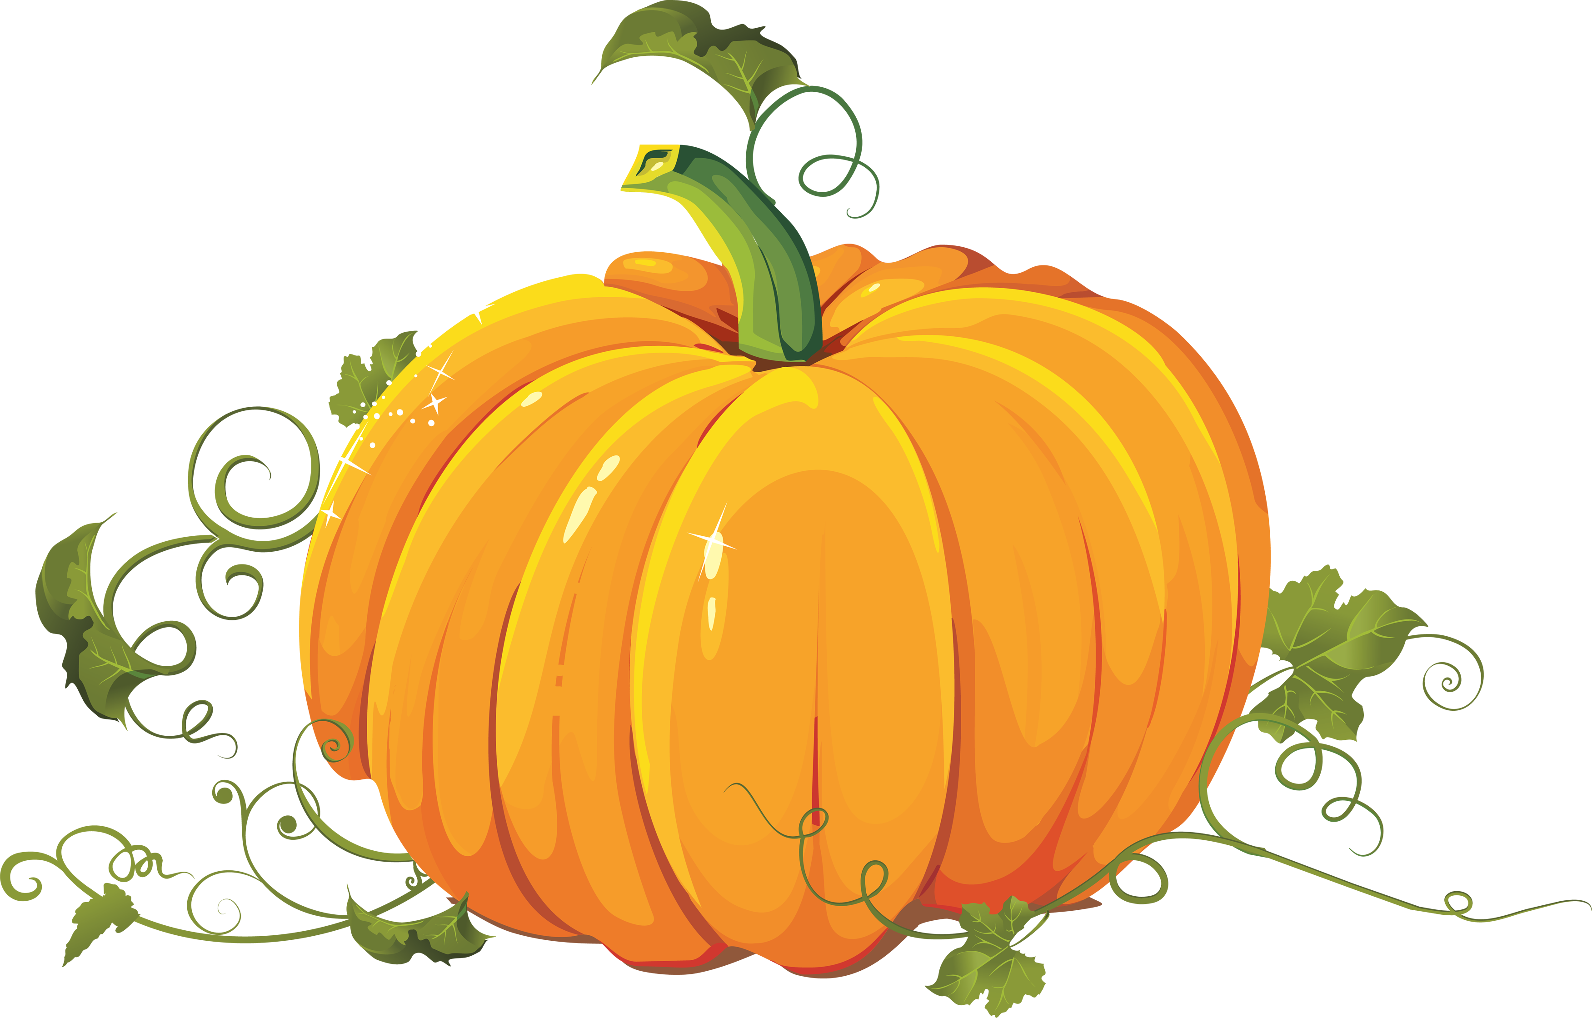
*Halloween Celebration information located in folder.

Things to work on at home
.
*Writing numbers 0-20
*Identify numbers 0-20
*Tying shoes
*Counting
*Using scissors to cut out shapes and along lines
*Add two groups together by writing an addition sentence (4 + 6 = 10)
*Writing letters A-Z (upper and lowercase)
* Sounding out small words that contain sounds we have worked on (a, b, c, f, h, i, j, m, o, p, s, t, u, g, d, r,n)
Example words: rat, tub, grin, nut, stop, wig, bug, dad, hot, dug, dust, rib, spin

Coats
The weather is starting to get chilly! Please send a jacket/coat or sweatshirt to school with your child each day. Recess and/or P.E. will be outside most of the time.

Spelling Words
at
hat
cat
can
cap
tap
map
mad
a
the

*We will have our first spelling test next Friday
10-30-20. You can help your student prepare for this test by having them practice writing these words at home.
Homework
Homework will come home in folder on Friday. Students should complete this on their own, with you reading directions. Please return by Thursday the next week.

